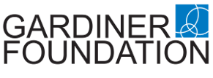
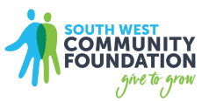
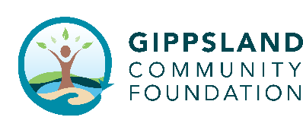
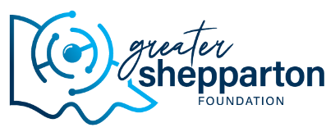


Gardiner Foundation Community Development Grants
2026 Guidelines

About Gardiner Foundation
Gardiner Foundation is a not-for-profit philanthropic organisation with a vision for vibrant, thriving Victorian dairy communities where people want to live, work and invest. From 2002 to 2025, Gardiner Foundation’s Community Grants program has invested over $2.5M across more than 600 community projects in regional Victoria.
Delivered in collaboration with regional community foundations, the program recognises the value of local insight and leadership in driving meaningful outcomes. In 2025, Gardiner partnered with Border Trust, Greater Shepparton Foundation, Gippsland Community Foundation and South West Community Foundation to distribute $150,000 in grants to projects that foster connection, wellbeing and resilience.
Funding of up to $10,000 is available for initiatives that promote social interaction, enhance wellbeing, enable digital inclusion, and improve access and mobility.

Community Development Grants
Gardiner Community Development Grants invests in locally led projects that strengthen the social fabric and connectivity of Victoria’s dairy communities.
Approaches to social connectivity may include, but are not limited to, initiatives that:
- Promote social interaction and community participation;
- Enhance wellbeing;
- Enable digital inclusion, and/or
- Improve mobility and access to community.
Projects must seek to benefit disadvantaged or marginalised people or groups in Victoria's dairying communities, particularly those that intersect with the dairy supply chain.
Grants of between $5,000 - $10,000 are available for:
- Deliver programs, events, workshops and initiatives that build social connection and/or improve mental health and wellbeing, particularly where cost-of-living impacts participation (e.g. reducing out-of-pocket costs, transport and access support).
- Invest in capacity building that strengthens local leadership, volunteer capability and community readiness, supporting long-term connection and resilience.
- Use the arts and creative practice to help people tell their stories, share lived experience and come together across generations and backgrounds.
- Strengthen food and fibre connections by bringing people closer to local stories, producers and the dairy supply chain; supporting understanding, pride and stronger community engagement (not only on-farm impact, but whole-of-community benefits).
- Purchase equipment and materials that enable community connection (e.g. resources that make it easier for people to gather, create, participate, or access services).

Eligibility
To be eligible for a grant, organisations must be either be:
- Non-profit (with either an Incorporation Certificate and/or an ABN) including place based organisations with a strong local presence, servicing Victorian communities where the dairy industry is a primary economic and social activity (refer to eligible LGAs in the Defining Dairy Communities section).
OR
- A social enterprise with models of moderate to high benefit for dairy communities.
Gardiner Foundation will not consider funding for:
- Activities that are partisan or religious in nature
- Activities that are already funded by Gardiner Foundation
- Retrospective activities (activities that have already occurred)
- Fundraising activities for an organisation or individuals
- Capital works that do not directly support community wellbeing
- Sporting activities that do not have a focus on alleviating disadvantage
- Any commercial or business activity that detracts from the dairy industry
- Direct food relief, including the purchase or distribution of food parcels, food hampers, grocery vouchers, gift cards, or other forms of immediate emergency assistance.

Application & Selection Process
Eligible organisations are invited by their local community foundation to submit a written application. Application timelines are specified by each respective community foundation.
Applications will be reviewed and selected by an independent panel selected by Gardiner Foundation.
Applicants will be notified of the outcome of their application in August/September, with grant payments distributed by 30 September 2026.

Grant value & timeframes
Grants will be awarded from a funding pool of $50,000 in each of Victoria's dairying regions Gippsland, Murray and South West. It is anticipated that 5-8 grants will be awarded in each region. Grants of up to $10,000 are available with smaller applications accepted from organisations with lower delivery capacity or funding needs, with an application minimum of $5,000.
Grants will typically be awarded for a one-year period, with a closure report to be submitted to the respective community foundation. The grant period may exceed one year with prior approval from Gardiner Foundation and the grantee's respective community foundation.

Defining a 'Dairying Community'
A dairy community in regional Victoria, Australia, can be defined as a rural area where:
- The dairy industry is a primary economic and social activity.
- There is a strong sense of community identity and shared purpose.
- The landscape and environment are shaped by the dairy supply chain including farming and businesses.
- There is a close relationship between the dairy industry and the wider local community.
Gardiner Foundation Community Development Grants will focus on the three eligible dairying regions of Victoria covering the following LGA’s as listed in the table below:
South West Region | Murray Region | Gippsland Region
Corangamite  Moyne  Colac Otway  Glenelg  Warrnambool | Campaspe  Moira  Greater Shepperton  Gannawarra  Towong  Indigo  Loddon  Wangaratta  Alpine | South Gippsland  Wellington  Baw Baw  Bass Coast  East Gippsland  Latrobe City

Assessment Criteria
The following criteria will be used to assess applications:
- Alignment with granting guidelines
- Awareness of - and contribution to - issues facing Victorian dairying communities
- Demonstration of consultation or collaboration with the dairy industry
- Stronger weighting towards LGAs with greater presence across the dairy supply chain, including farm businesses, processing and dairy service providers.

Contact
For further information on the grant guidelines or application process, please contact:
Murray:
Greater Shepparton Foundation | Border Trust
Amanda McCulloch - Executive Officer | Sue Gold - Executive Officer
hello@communitygrants.org.au | hello@communitygrants.org.au
0447 400 443 | 0485 858 183

Gippsland: South West:
Gippsland Community Foundation | South West Community Foundation
Michelle Dowsett - Executive Officer | Alison Byrne - Executive Officer
mdowsett@gippslandcf.org.au | eo@southwestcommunityfoundation.org.au
0499 241 917 | 0437 756 082

