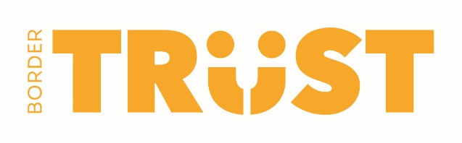

COMMUNITY WINDOW PROJECT
From early 2022, one community organisation per month will be promoted by Border Trust to showcase their work or a particular fundraising event/campaign. This will be done through signage on our Olive Street office windows together with an invitation for representatives from the organisation to be our guests at a morning tea to talk to invited community members about the work they do.
Our aim is to connect people who care to local causes that matter. To register your interest in participating as one of our showcased organisations, please complete this form and return to admin@bordertrust.org.au. Please register your interest by 15.12.2021. Successful applicants will be notified early January 2022. Our thanks to Albury City for their Community Grant which has enabled this project.
Organisation Name & ABN
Contact Person
Email & Phone
Organisation Location
Organisation Purpose
Month you would like to be showcased. | 2022  March  April  May  June  July  August
Do you have something special going on during that month or would you use it for general promotion | Special purpose i.e. event  General promotion
If for something special, please tell us what that is
Do you have a logo or artwork that would be available for our use?
Will you or a representative be happy to talk at an informal morning tea gathering?

If you would like to discuss this before you apply, please contact Kate Weiss on 0409 567 553 or admin@bordertrust.org.au. Please note Kate works on a Monday and Tuesday.

